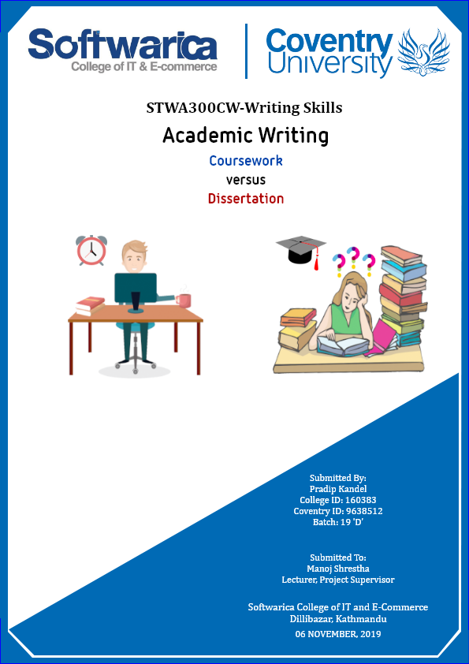

# Introduction

Academic writing is a work produced for several reasons so a simple definition of academic writing is hard to come by (Your Dictionary 2018). However, in an educational field, academic writing is a process of breaking down ideas and producing a formal written work to fulfill the requirements of a college or a university. It is about evidence-based deductive reasoning and discussing the ideas about a topic with an analytical approach. Students, professors, and researchers use academic writing to share their ideas and make arguments to engage in scholarly conversation. Books, essays, research papers, dissertations, thesis, conference papers are some documents where academic writing is widely used (Valdes 2019). Descriptive, analytical, persuasive and critical are four main types of academic writing (The University of Sydney 2019). The report provides detail discussion and analysis on coursework and dissertation with their similarities and differences using descriptive and analytical types of academic writing.

## Characteristics of Academic Writing

* Planning: Before writing a paper, there should be a certain amount of planning.
* Outline: It is a must for academic writing to have a certain outline that helps to ensure content is on the right track.
* Tone: A formal and logical tone is required avoiding slang words, abbreviations, etc.
* Language: A clear (unambiguous) language is required with the precision of right words placing to explain the content.
* Punctuation: Punctuation marks are required where appropriate to narrate the writing.
* Point-of-view: It should not support anyone’s opinion rather it should support facts.
* Approach: Deductive reasoning is required to convey the conclusions of writing.
* Academic conventions: Citation and reference are an important part of academic writing to acknowledge the source of any ideas, data, findings, and quoted text.

(Your Dictionary 2018)

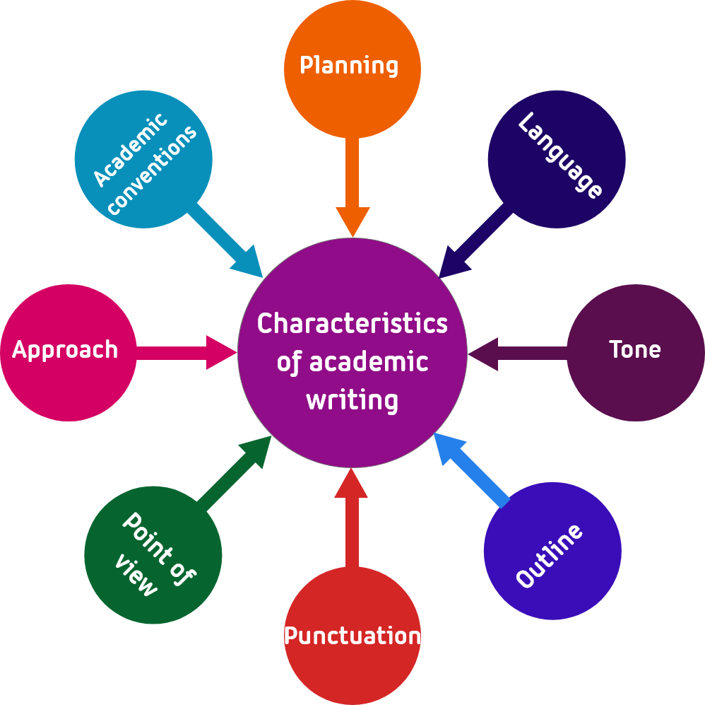

Figure 1: Characteristics of Academic Writing

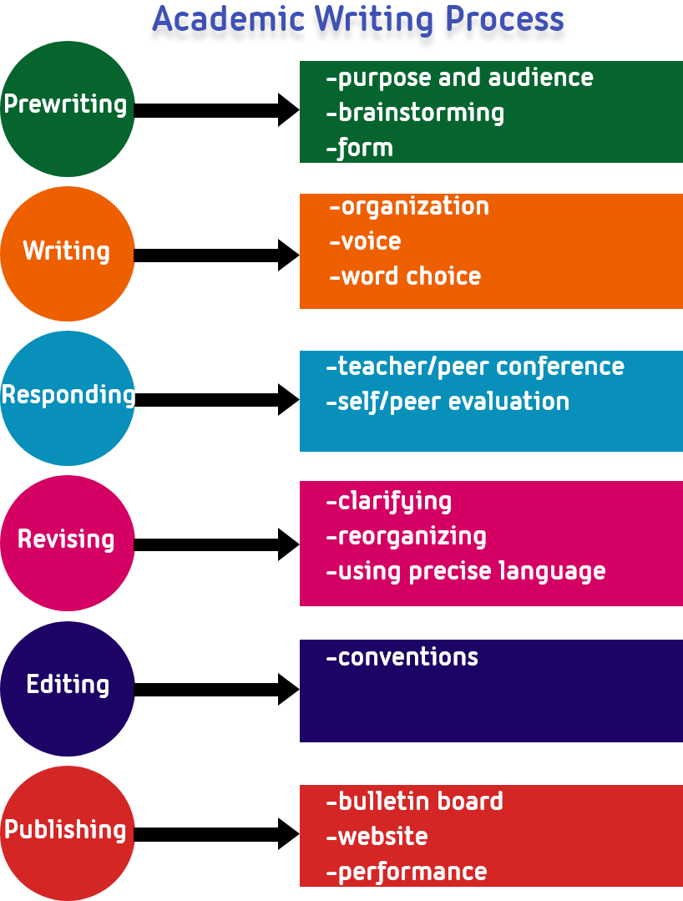

Figure 2: Academic Writing Process

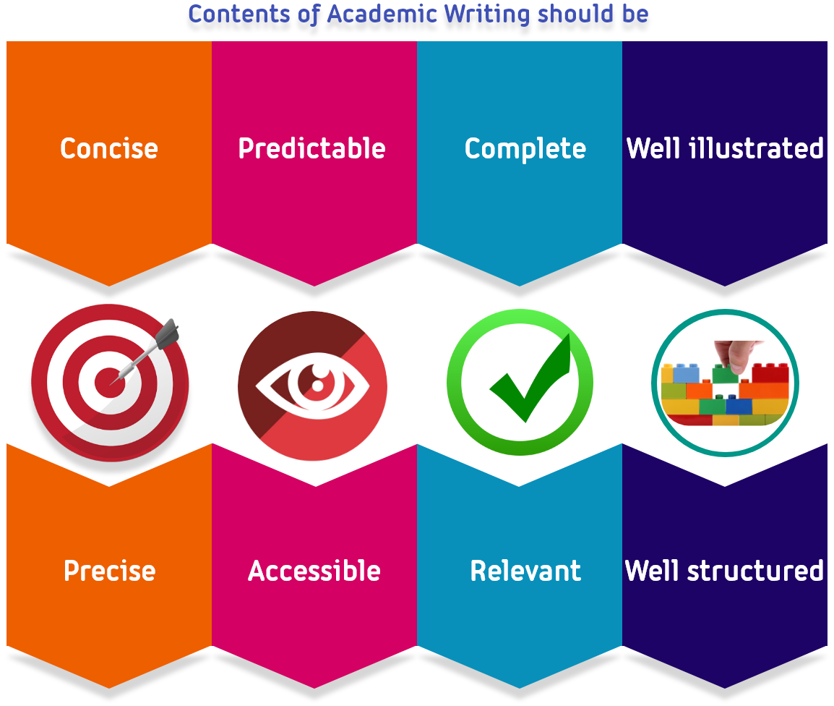

Figure 3: Quality attributes for academic writing’s content

(Planning Tank 2019)

# Coursework and Dissertation

## Coursework

Collins English Dictionary (2019) defines coursework as “written or oral work completed by a student within a given period, which is assessed as an integral part of an educational course”. Coursework is a systematic and structured approach for writing formal essays and assignments that should be clear, concise and focused. The main goal in coursework writing is to complete the given tasks/requirements at a certain interval of time. It is not complex and complicated however; it should have a formal style and structure with certain writing conventions and vocabulary (Planning Tank 2019).

The students of higher education institutions often practice it as a part of their assessment. John T.E. Richardson’s (2014) research paper says that in the UK and other countries, assessment through coursework in higher education has increased over the past 40 years. It is a learning process for students to prepare them for carrying out tasks efficiently and effectively. It should answer the questions with a clear understanding of the subject using appropriate language and tenses. Most formal academic writing guidelines are set differently by different universities. Nevertheless, it has clear criteria against which it will be graded. The art of interpreting the questions and generating ideas on how to tackle them is important to acknowledge any coursework. Project work, assignments, practical work, experiments are some examples of coursework.

Usually, coursework is divided into three main sections introduction, main body and conclusion. The introduction part presents the work that is to be done with background information, the main body presents the points that support coursework and conclusion presents the key message as illustrated by overall coursework and further improvements. The main body should be structured in a logical order to make it easier for the reader to follow and understand (JustBuy Essay 2019).

## Dissertation

In the English language, the word dissertation was first used in 1651 stating its definition as “an extended written treatment of a subject” (Royal Literary Fund 2019). Collins English Dictionary (2019) defines a dissertation as “a long formal piece of writing on a particular subject, especially for a university degree”. A dissertation is a long piece of writing which is partly taught and partly researched or completely researched (UKEssays 2018). Usually, a dissertation is a complete research project that is aimed at solving a particular problem or contribute to add value to the existing knowledge on a certain area of study. It can be done as a part of an academic degree or on personal interest.

Dissertations are mostly done as a part of an academic degree. A dissertation is not something that is never done before rather most dissertations are enhanced versions of previous researches with some new findings and improvements about the subject. It helps researchers to build depth knowledge in their area of interest. In addition, it is an excellent opportunity for researchers to experience the process of producing knowledge and develop intellectual skills. The author must show his/her mastery to prove the point he/she is trying to demonstrate. The author must investigate and discuss the subject with critical analysis weighing both pros and cons (Royal Literary Fund 2019).

Dissertations usually do not have a standard structure. The structure of the dissertation depends on one’s location, discipline, topic, approach, and university. However, it is mandatory to include sections such as literature review, methodology, findings, discussion, conclusion, and references in any dissertation (Scribbr 2019).

# Writing Process

Coursework writing process is generally easier as compared to dissertation. Before writing any coursework, it is mandatory to attend lecture session, receive the question, discuss and understand the questions. Likewise, students need to plan the writing considering the deadline for each task. Furthermore, students need to brainstorm the questions to find the relevant information for writing. Moreover, at the end, students need to write the coursework with appropriate structure and get feedback from supervisor. Working product, documentation, presentation slides are outputs of most coursework.

On the other hand, dissertation writing process is complex and hard as compared to coursework. Unlike coursework, students need not receive question in dissertation rather choose suitable topic for research. Before writing dissertation, it is necessary to conduct preliminary research and discuss with supervisor. In dissertation writing, it is mandatory to draft research proposal with aims and objectives of research. Students need to consider legal and ethical aspects in dissertation writing in contrast to coursework. Furthermore, literature search is obligatory in dissertation writing. Just like in coursework, dissertation also requires certain working prototype, feedback from supervisor, documentation and presentation slides as output.

## Coursework

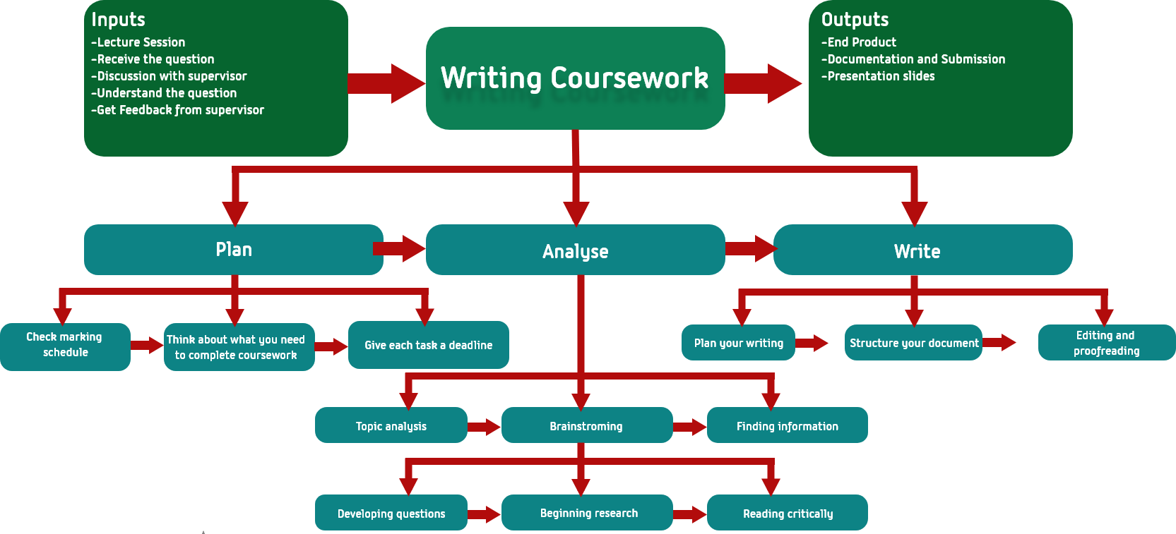

Figure 4: Coursework Writing Process

## Dissertation

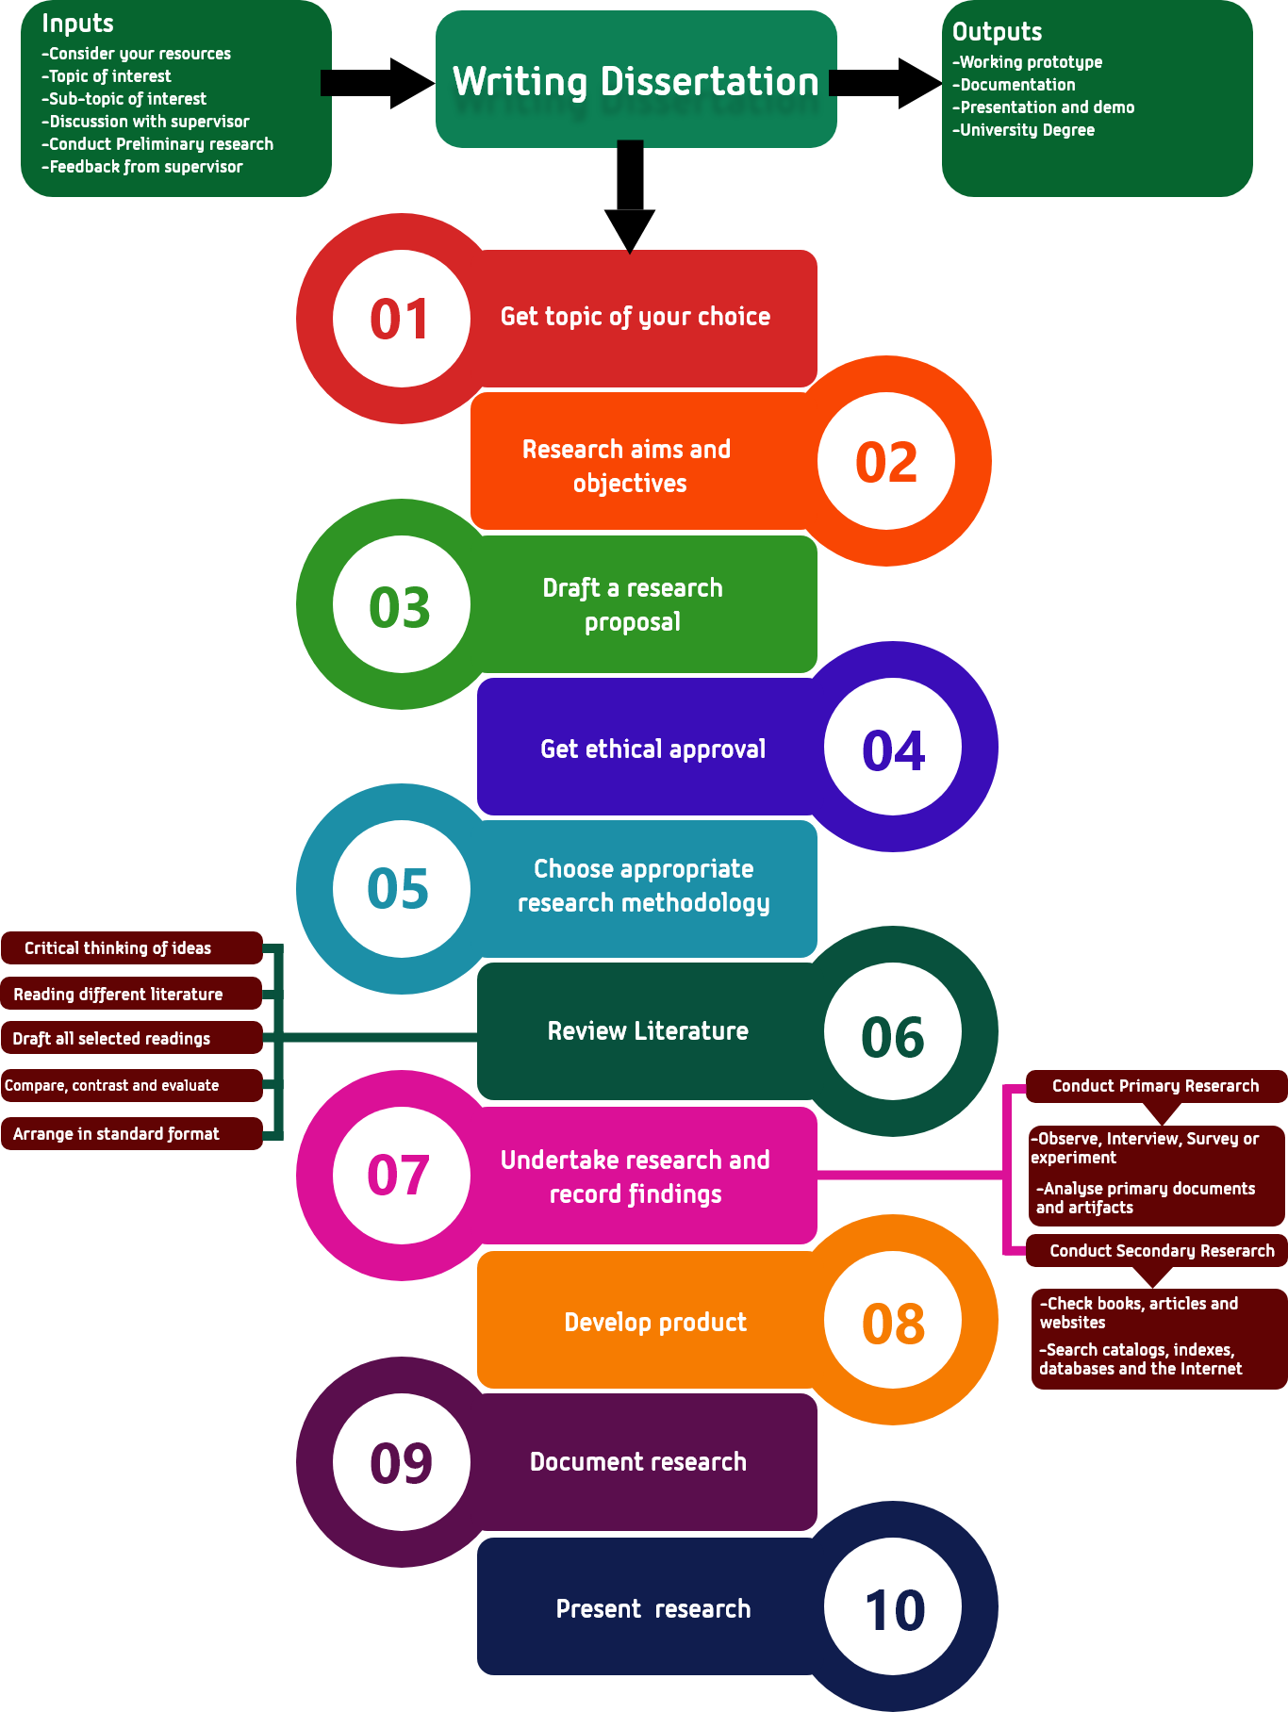

Figure 5: Dissertation writing process

# Similarities and Differences

Coursework and dissertations are both parts of academic writing. However, they are different and similar in many aspects. To begin with, there is a difference in topic choice. Coursework often has a predefined topic while one can choose the topic of his/her interest in the dissertation. Next, there is a difference in structure. Coursework has its predefined structure. On the contrary, the dissertation does not have any standard structure. However, both are the same in the case of language and grammar as both are formal documents that are written with formal and logical tone avoiding slang words and ambiguous language. Moreover, the necessary document formats such as font type, font style, fort size, spacing, margins, paper size, citation and referencing styles, etc. are similar in both the documents and these constraints are usually set by the university. In addition, coursework is completely guided by teachers while the dissertation may not be fully guided by teachers; however, there is teacher support if needed. Therefore, regular feedbacks from the supervisor is important in both the documents to enhance them. Coursework often requires only appropriate research. Unlike coursework, the dissertation requires in-depth research (primary and secondary research). There is always the risk of plagiarism in both the documents. Therefore, both the documents should have a little or a considerable amount of plagiarism. Likewise, there is a difference in credit and grading between the two. Coursework often carries lower credit as compared to the dissertation. Besides, coursework is graded if it is fully completed while the dissertation is graded in parts such as quality attributes, research data, analysis, etc. Nevertheless, both of them are graded as a part of a course and hence contribute to completing the course and ultimately gaining a university degree. Similarly, there is a difference in document length and duration between the two. Coursework has less word count and less duration as compared to the dissertation. Whether or not coursework has a findings section, the dissertation must have a findings section that should be based on research data. Finally, there is some difference in reward between the two. Coursework credits students with success in a single module. In contrast, the dissertation credits students with a university degree.

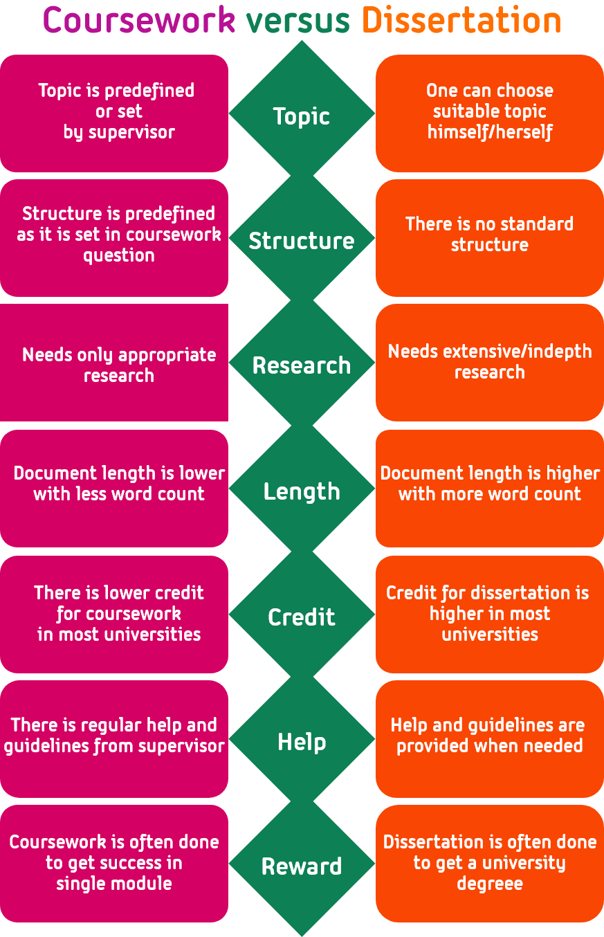

Figure 6: Differences between coursework and dissertation

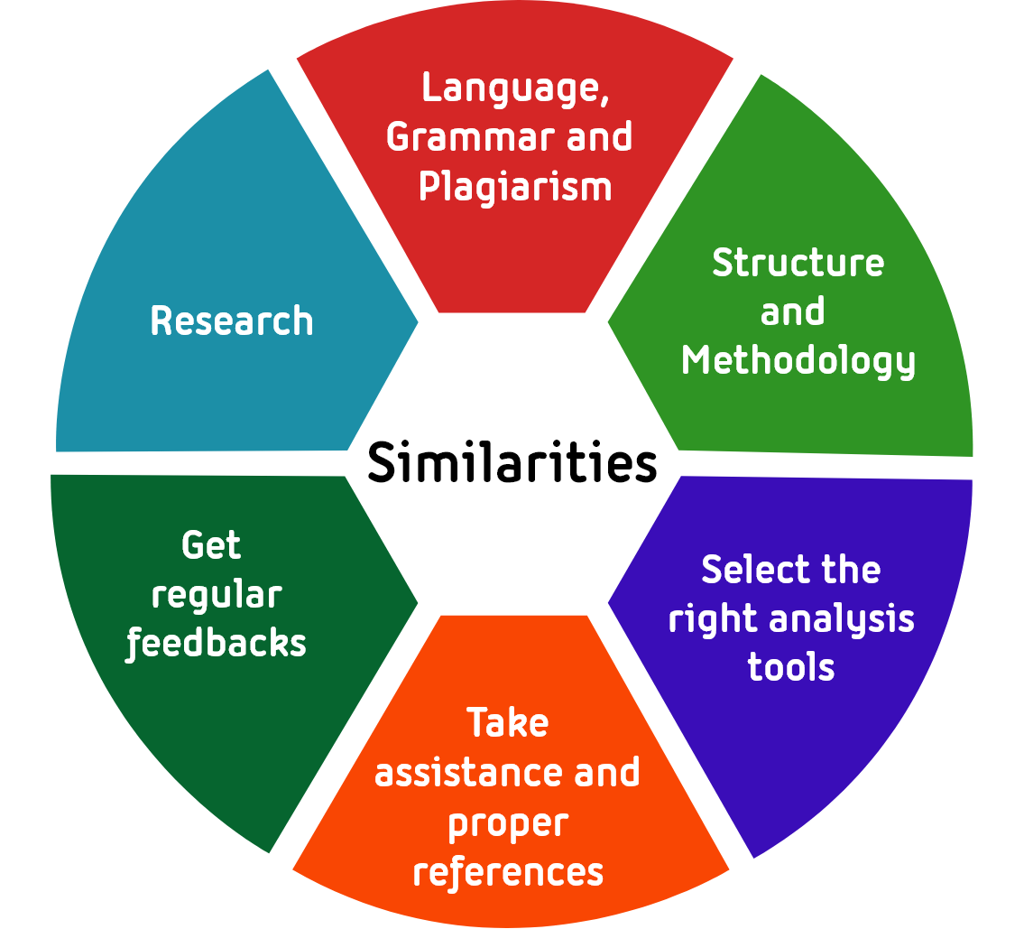

Figure 7: Similarities between coursework and dissertation

# Benefits

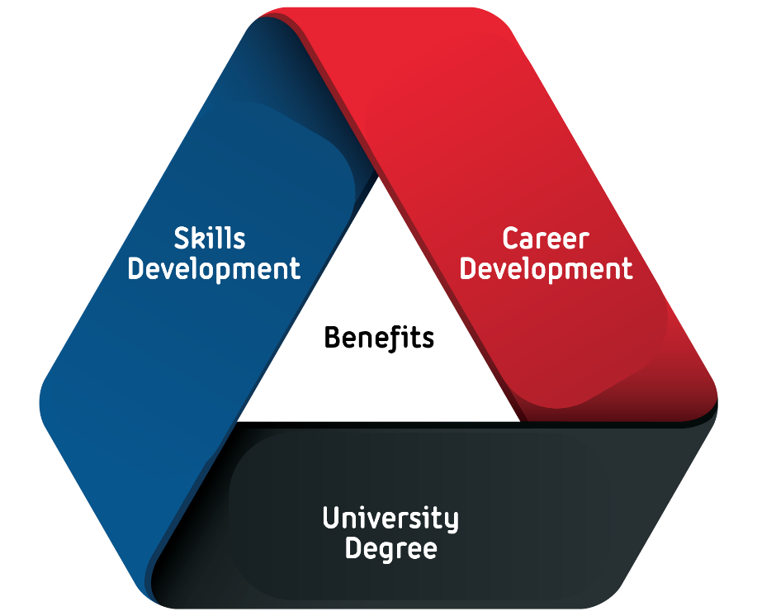

Figure 8: Benefits of coursework and dissertation

* Career Development: Coursework and dissertation are both an excellent opportunity for students to prove their capabilities and develop intellectual skills. In addition, they guide students towards knowing their passion/interest with both theoretical and practical knowledge, which would help them to build their career later.
* Skills and Personal Growth: Both of them reward students with problem-solving skills, which constitutes reading, writing, and thinking skills. Furthermore, they help students to develop their interpersonal skills such as communication, time-management and presentation skills.
* Acquire analytical and cognitive skills: Dissertation always needs an analytical mind and if one completes any dissertation, he/she improves his/her analytical skills (Anderson 2017).
* Degree acquisition: In most of the case, the dissertation is written for acquiring a recognized degree. Moreover, once we have degree and skills, we can utilize them in productive works, which ultimately drive us towards a good career.

# Challenges

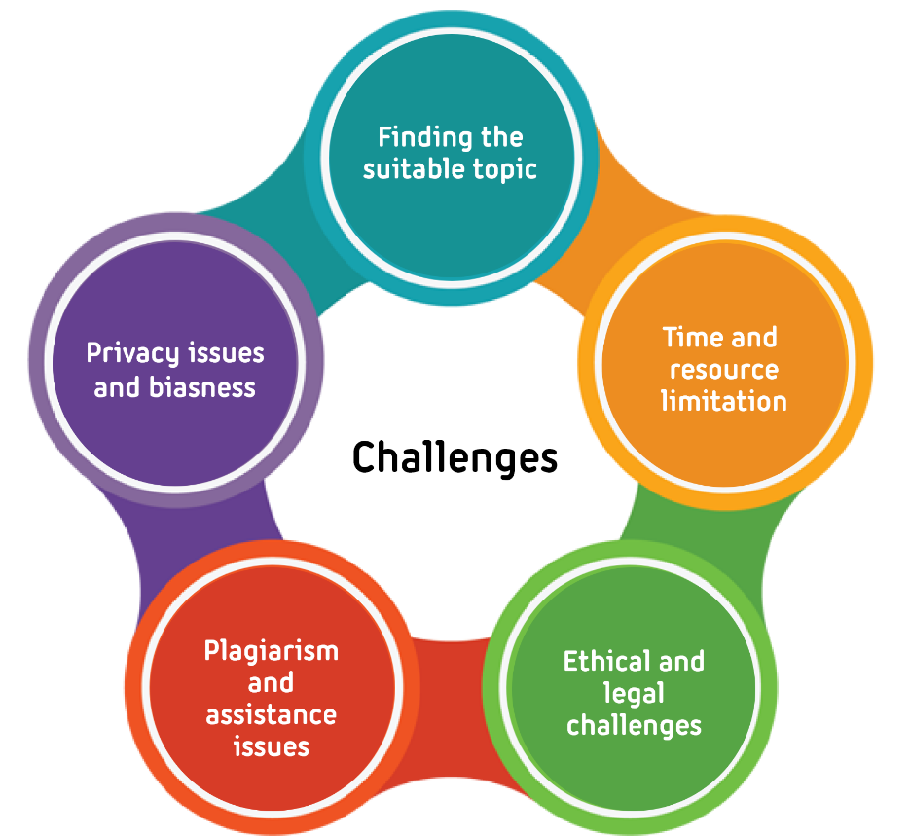

Figure 9: Challenges of writing dissertation and coursework

Teachers and Tutors often guide coursework while the dissertation is an individual task that may not be fully guided by teachers. Therefore, there are more challenges in writing a dissertation as compared to coursework.

* Finding the Topic: The most difficult task in dissertation writing is finding the topic he/she is interested in.
* Resource Limitation: Students may not find the resources such as books, articles, journals, and research papers, etc. that they need for literature. In addition to this, students find it difficult to manage time and hence may not complete the task on given time.
* Privacy Issues: In any dissertation, there is some kind of data used and one cannot guarantee the privacy of those data.
* Ethical and Legal Challenges: This is always the case in any research project. Students must conduct and write research considering ethical and legal aspects.
* Plagiarism: The content in both coursework and dissertation is generally paraphrased from various sources such as books, websites, journals, etc. so there is always a chance of plagiarism.
* Formatting and Documentation: Students often get trouble in formatting the document as every school/college has a different style of formatting and different terms, rules and values.
* Poor support from supervisor: Supervisor’s support is always needed to enhance the quality of writing in both coursework and dissertation; however, students may not get the necessary support.
* Communication: There is always a chance of miscommunication and misunderstanding between team members in group coursework.

(UrbanGeekz 2017)

# Conclusion

To conclude, two parts of academic writing, coursework and dissertation, are analysed and discussed in this report. The basic concepts of academic writing with its characteristics are discusses to begin the report. Likewise, the differences and similarities between coursework and dissertation are identified and demonstrated clearly with figures where appropriate. The concepts, theories, methodologies and issues of coursework and dissertations are clearly mentioned from the extensive research of various sources such as books, websites, articles, etc. Furthermore, benefits and challenges of writing coursework and dissertation are discussed at the end of the report. In this way, the report provides the comparison between coursework and dissertation.